Team Avengers
S014-062
Scope and Mission
Predicative
Henry Thay
Tim Kim
William Perry
Hung Le
German Villarreal

Table of Contents
1. Document Version 3
2. Team Contact Information 3
3. Description 3
4. Proposed Solution 3
5. Stakeholders and Users 3
6. Proposed Technology 3
7. Assumptions 3
7.1. Non-Technical Assumptions 4
7.2. Technical Assumptions 4
8. Project Goals, Tasks, Features 4
9. Deliverables 4
10. Out of Scope 4
11. Existing System 5
12. Diagrams 5
12.1. Client Diagrams 5
12.2. Team Diagrams 5
13. High-Level Schedule 5
14. High-Level Work Breakdown 5
15. Risks and Issues 5

Document Version
Version | Description | Date | Author(s)
1 | Created | 24/04/2014 | Henry Thay  Tim Kim  William Perry  Hung Le  German Villarreal
2
3
…

Team Contact Information
We are team Avenger aka. Team 19.
Name | Email
Henry Thay | Henry23t@gmail.com
Tim Kim | neotimmy@hotmail.com
William Perry | Wj.perry92@gmail.com
Hung Le | fifthredux@gmail.com
German Villarreal | Vo.german@gmail.com
Supervisor | Email
Tejinder Randhawa | Trandhawa1@my.bcit.ca

Description
Create a database of IP addresses that are mapped to GPS longitude and latitudes coordinates. There will also be another database containing the closest hops between the IP addresses. These are later used to estimate location of an unknown IP addresses.
Current IP geolocation are not accurate enough and limited to city level granularity, our client are looking for a better solution.

Proposed Solution
Our team will hopefully be able to provide our client with the two initial databases consisting of known IP addresses with GPS location and connecting neighbor IP addresses.

Stakeholders and Users
- Predicative
- Ben Critchfield CEO
- Jay Pozo
- Nathan

Proposed Technology
Java will be used to map GPS location to IP addresses
MongoDB for the database

Assumptions

Non-Technical Assumptions
- This project should take the full 5 weeks to complete.
- We will only track IP addresses within the lower mainland

Technical Assumptions
- Using mongoDB for the database
- Using java to create an app to locate IP addresses
- The team will be creating a back-end system

Project Goals, Tasks, Features
The client is trying to achieve accurate IP geolocation to provide this service to other companies for accurate location aware advertisement.

The client has 2 milestones for use to complete.
The first milestone is to create a database of IPs with known GPS coordinates
Being able to match IPs with longitudes and latitudes.
The second milestone is to be able to get a GPS coordinate from an unknown IP

Deliverables
Deliverable | Description
Database - Documentation | A doc on how to use the database and the basic commands to be able to use the database
Database – Code | A script to create and populate the database

Out of Scope
- GUI Design and user interface are not a part of this project.
- Fully fleshing out the databases
- Programatic approach at finding IP Addresses tied to a location

Existing System
The client has a way to map IP addresses to a neighborhood level.
We plan on using IP tracing software that has already been developed to improve for our needs.

Diagrams

Client Diagrams
To be discussed.

Team Diagrams
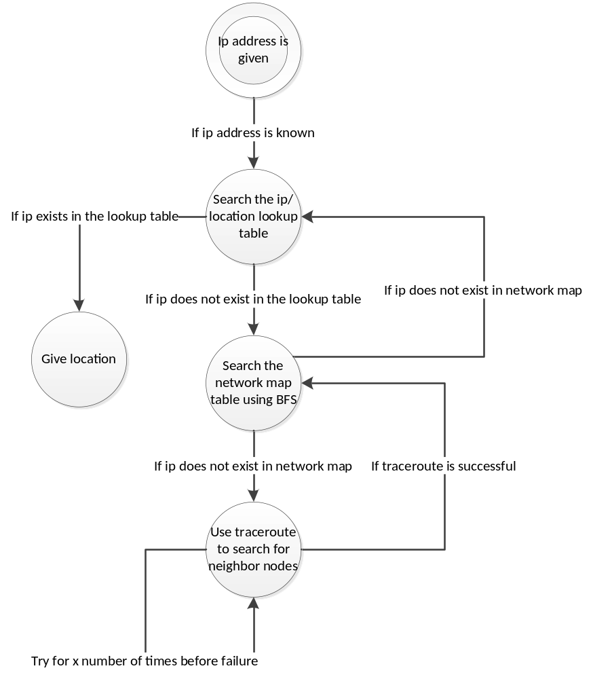

High-Level Schedule
Important tasks over time are broken down as follows:
Week 1 | - Brainstorming and research of current technologies and implementations  - Research technologies to use  - High level design  - Complete documentation
Week 2 | - Create initial database to set structure  - Add known IP addresses and locations to the database  - Begin finding IP addresses and GPS locations  - Create server application that will ping a destination and count the nodes in between
Week 3 | - Continue developing the server application to store the intermodal nodes into the database and estimate the distance between nodes comparing with known locations
Week 4 | - Heavy testing and debugging
Week 5 | - Complete thorough documentation

High-Level Work Breakdown

Owner | Description | Completion Date
NAN

Risks and Issues
Risk or Issue Description | Potential Impact | Mitigation/Resolution Steps
Communication | Delayed productivity due to uncertainty. | Use online communication services such as Skype, Basecamp.
Privacy Concerns | Granularity of project may change | Speak to supervisor and client.
Losing a team member | Delayed development | Commit to your team and increase communication throughout the development process. All members must show up to every lab and report progress.

